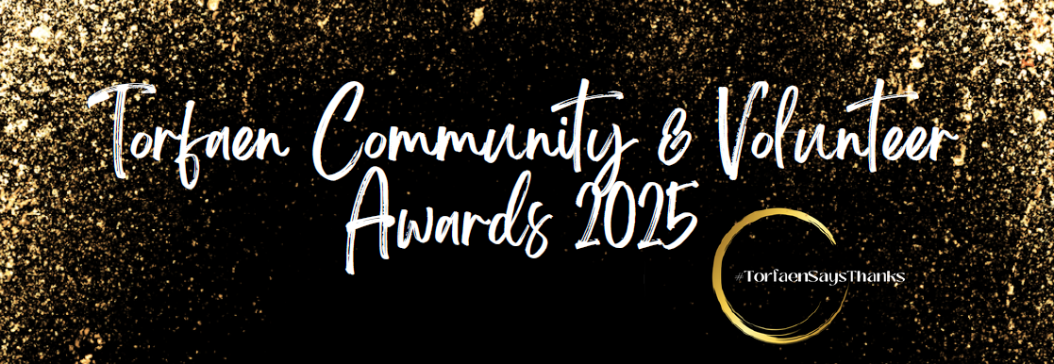
The awards aim to recognise the outstanding commitment of volunteers, community groups, organisations, and businesses within the communities of Torfaen, and so we ask for your help in identifying those:
Have you ever wanted to highlight the qualities of someone who shows remarkable selflessness, devotion, and service to the community and who, in your view, deserves wider recognition?
Perhaps you want to bring attention to an organisation whose activities have given a buzz to your community? If so, now is the chance you have been waiting for!
If you know someone who deserves a chance to be recognised for their commitment, dedication and hard work please take a few minutes of your time to nominate them by completing this form.

CLOSING DATE FOR NOMINATIONS
Thursday 31st July 2025 at 12 midnight.
Categories
The categories for nominations are: -
Category | Award Description
Adult  Volunteer/s | This award recognises an individual (26yrs+) who gives unconditional support to their organisation, dedicating great time and effort, often ‘behind the scenes’. They may undertake one or several roles within an organisation. With devotion and professionalism, they do not seek reward but their efforts over the past year mean they are more than deserving of this accolade. Supporting evidence must refer to their contribution and the level of commitment given by this person in both quality and quantity.  - Volunteer at a local community project such as a foodbank, tin, on the wall etc  - Volunteer at a local non-profit event
Young  Volunteer | This award is to recognise a young person aged between 11 and 25 who has shown a real commitment to their volunteering. Supporting evidence must make reference to their contribution and the level of commitment given by this person in both quality and quantity.  - Volunteer at a local community project such as a foodbank, tin, on the wall etc  - Volunteer at a local non-profit event
Trustee  Volunteer | This award recognises an exceptional and influential trustee who demonstrates outstanding dedication and commitment to an organisation. Supporting evidence must refer to their contribution and the level of commitment given by this person in both quality and quantity.
Sports  Volunteer/Group | This award recognises an individual or volunteer-led clubs, teams in Torfaen whose contribution to sport has made a difference by providing their time to support sport & recreational activities in Torfaen.  For example, nominee’s may have  - Used sport as a way to tackle social isolation/loneliness.  - Used sport as a tool to positively impact the lives of participants.  - Used sport to promote the inclusion of marginalised groups.  - Volunteer at a community sports club  - Coach a youth sports team  - Volunteer with an organisation that promotes diversity in sport;  - Support a local recreation centre  - Organise volunteer led outdoor activities  - Share their time to support community recreational activities  - Volunteer to teach inclusive physical activities  - Take part in a committee for a local sports programme  - Or take part in any other volunteer activity that supports sport or recreation!
Health  Volunteer | This award recognises an individual that has actively contributed to improving the health and wellbeing of others or has supported the promotion and improvement of health and wellbeing in their community. For example, nominees may have  - Worked together to help reduce social isolation and improve social connectivity.  - Identified and challenged health inequalities.  - Raised awareness of/promoted the importance of supporting mental wellbeing.  - Run a support group for those affected by mental health  - Volunteer with a charity that supports people with a disability  - Support an organisation that advocates for those with a certain illness or condition  - Volunteer with a day care centre, nursing home or independent living community  - Provide activities and classes designed to include people with a disability or long term illness  - Accompany patients to hospital appointments  - Or take part in any other volunteer activity that advances people’s health or well-being!
Environmental Volunteer / Group | This award recognises an individual or group who is committed to the promotion and protection of our environment, or the preservation of our rich cultural heritage.  For example, nominees may have  - Contributed to a project to preserve and conserve our natural environment.  - Dedicated their time to improving, maintaining or conserving a heritage project or site.  - Promoted or carried out projects to recycle, reduce waste or reduce their carbon footprint.  - Participates in a clean up project or local litter pick  - Support a community garden or park  - Organise a green agriculture initiative  - Take part in environmental protection projects  - Champions a sustainability programme  - Or take part in any other volunteer activity that supports the environment
The Heart of the  Community  (Community Group of the Year) | This award recognises teams of volunteers, groups, or community councils whose support has resulted in a positive impact on their local community.  For example, nominees may have  - Worked on a community project to improve their local area.  - Empowered local people to take action on matters that are important in their community.  - Worked together to run activities for local residents.
Business  of the Year | This award recognises a business that encourages, provides and/or supports its workers to volunteer in the community, provides skills and expertise to support or mentor local groups, or sponsored much needed work for local organisations.
Arts, Culture & Heritage Volunteer or Group | This award recognises those who contribute to the cultural life of Torfaen through encouraging and providing engagement with music, arts, creative writing, dance, history, and heritage. This category is open to an individual volunteer, or to an organisation that enables volunteers to participate in and promote cultural experiences.  Here are a few examples of volunteer activities that would fit into this category:  - Volunteer at a community event  - Participate in a local theatre group  - Volunteer at a museum or art gallery  - Support a local cultural institution  - Organise volunteer cultural tours  - Share their time to support community choirs, dance groups, art groups, heritage groups  - Volunteer to teach art, music or dancein a community setting  - Showcase the diversity of art and culture in Torfaen  - Takes part in any other volunteer activity that supports art, culture or Heritage
Children & Youth  Group Award | This award recognises volunteers and voluntary groups who support children and youth in Torfaen.  For example:  - Volunteer at a local youth group  - Act as a mentor to at risk children  - Participate in a local afterschool group  - Volunteer to share their skills and teach young people  - Organise activities for children in need of additional support  - Share their time with a children’s support line  - Support a charity that advocates for children’s causes  - Facilitate skills based or social programmes for youth  - Or takes part in any other volunteer activity that supports children or young people!
Community Leader  Award | Great groups rely on inspirational people – those special individuals who have not just chosen to give their time to improve their community but who have been able to motivate and support others to do likewise.  This can be an individual who has gone above and beyond in commitment and passion for their community. Responding by giving outstanding service and support during times of crisis this year or responding to the needs of their community
Neighbour of the Year Award | This award celebrates someone who goes out of their way to help people around them, making their street or community a better, friendlier place to live. Whether through small acts of kindness, being dependable, or helping in tough times, this person brings people together and makes a real difference. This award celebrates someone who goes out of their way to help people around them, making their street or community a better, friendlier place to live. Whether through small acts of kindness, being dependable, or helping in tough times, this person brings people together and makes a real difference.
Gwent High Sheriff | The High Sheriff presents various awards during the year to thank people for their contributions to the work of the justice system, to combat crime or to support people in the community – All nominations from all categories will be presented to the High Sheriff of Gwent for him/her to make a decision on the recipient(s).
Rules of Nominations
Rules of nomination are as follows: -
Nominations can be made for volunteers, community groups, organisation, and businesses, who have performed activities or a service that have benefited Torfaen communities and residents.
Nominations are free and there is no limit to the number of nominations that one person or organisation can make.
When a nomination is made, the nominator must confirm within the nomination form that they have gained the consent of those nominated to put their names and contact details forward to TVA for the sole purpose of the awards.
Nominators may be asked to provide additional evidence or materials after submission.
You can-not self-nominate or nominate a family member or some you have a close personal association with but can choose to nominate other volunteers, community groups and businesses of which you have an association with, this would include a Trustee or volunteer from within your organisation.
Nominations for the 2023 Awards must be submitted to TVA by midnight of Wednesday, 31st July 2023.
Nominations can be made in two ways, through accessing the following link: https://tvawales.org.uk/volunteer-awards
completing and submitting the online form
by downloading the nomination form and sending to communications@tvawales.org.uk or posted to TVA Office, Pontypool.
Information you submit as part of a nomination may be included in promotion and publicity by TVA.

A copy of the Judging Panel Rules are available on request.

Submission Details:
Please return by Thursday 31st July at 12 midnight to:
Torfaen Voluntary Alliance
E-Mail: communications@tvawales.org.uk with the subject ‘Torfaen Community & Volunteer Awards Nomination’.
Mail: Torfaen Voluntary Alliance, Portland Buildings, Commercial Street, Pontypool, Torfaen NP4 6JS

If you have any questions or require any information, please feel free to contact team at TVA on 01495 365610 or email communications@tvawales.org.uk

Nomination Form
Please fully complete all sections of this form clearly in block letters.

Details Of Person/Group/Business Nominated
Name of Person/Group/Business
Address

Postcode

Telephone

Email

Please tick only one category that you would like to nominate the person/group for
Adult Volunteer of the Year (25 years and over)
Young Volunteer of the Year Person (Under 25 years)
Trustee of the Year
Sports Volunteer / Group of the Year
Health Volunteer of the Year
Environmental Volunteer/Group Award
The Heart of the Community (Community Group of the Year
Business of the Year
Arts Culture & Heritage Volunteer or Group
Children & Youth Group of the Year
Neighbour of the Year

Fully describe the activities carried out that has inspired you to nominate this individual/group/business
(continue on one side of A4 paper, if necessary, to a maximum off 500 words)
How do you feel the activities listed benefit the community?
(100 words maximum)

Why do you think this individual/group/business deserves to be recognised in this category?
(100 words maximum)

Details About You, The Nominator
Full Name
Relationship to Nominee
Address
Postcode
Telephone
Email
I confirm that the information given is correct to the best of my knowledge, this nomination has been submitted with the permission of the nominee and I have read and agree to abide with the rules of the scheme.
Signed
Date

PLEASE ENCLOSE A PORTRAIT IMAGE OF THE NOMINEE WITH THIS APPLICATION

