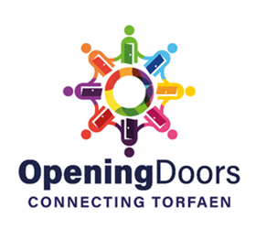
Opening Doors
Connecting Torfaen

Hub: __________________ meets Opening Doors aims and priorities:

Providing a Focal Point for the Community  Helping to combat loneliness and isolation by providing a warm, safe space for people to connect and engaging in activities within the community | ü
Promoting Health and Wellbeing  Assisting people in the community to access health & wellbeing services | ü
Providing Access to Services, Agencies, and Partners  Giving the community access to a range of services, partners, and agencies,  and actively signposting to a wide range of services | ü
Connecting with Other Opening Doors Hubs  Working together with other Hubs within cluster areas, sharing information, ideas, and good practice, to benefit the community and not duplicate services | ü
Providing Information about Other Services and Activities  Displaying and promoting information for the community to readily access a range of services and activities from other venues, partners and agencies | ü
  Promoting Activities and Services  Actively promoting activities and services by digital and non-digital methods | ü
Providing Information & Documents for Health Check  To ensure the Hub is a safe place for the community to connect with all policies in place and up to date Support with governance can be provided | ü
Training – Attend Training Sessions  Including Connect 5, Safeguarding, Governance, First Aid, etc as required | ü
Networking Forum & Cluster Meetings  Attending quarterly networking forums & cluster meetings to  connect with other Hubs, partners, and agencies | ü

The above Hub commits to Opening Doors aims and priorities.

Signature: | _______________________ | Date of Assessment: | _________

